Calling people from diverse backgrounds, especially minority groups!

Familiar with PPI in research?

Would you like to become a member of the
PPI Ignite Network Public Advisory Board?

Introduction
The PPI Ignite Network is a network that supports public and patient involvement (PPI) in research in Ireland. PPI means, for example, that if research is about young people, then young people should be involved in deciding what the research should be about, in planning research from the start and in sharing the results of research, especially with other young people.
There are seven Universities at the centre of the Network working with over sixty local and national partners. You can find out more about the PPI Ignite Network online. The Network is funded by the Health Research Board and the Irish Research Council.
We are setting up a Public Advisory Board, to bring the voice and perspective of the public across Ireland to help to guide how the Network operates.

Diverse Ireland
Ireland now is home to a culturally and linguistically diverse population. It is important that our Public Advisory Board reflects this diversity, so we are reaching out with this targeted call.

What will a member of the Public Advisory Board do?
Members of the Public Advisory Board will advise the Network on the work it does and will:
- Attend meetings of the Public Advisory Board (mainly online)
- Contribute to discussions at the meetings, drawing on their own lived experience
- Sometimes, before or after meetings, review documents, or audio or video recordings
- Advise the Network on its ongoing work and future plans
- Have opportunities, if a member is interested, to get involved in some additional Network activities, for example, to contribute to a working group on equality and diversity, or represent the Public Advisory Board on other groups or at PPI events.
- Potentially have opportunities to sit on the Network’s Steering Group

How to let us know you would like to become a Board member
Complete the Expression of Interest form on page 4 below and email it to hello@ppinetwork.ie .

What backgrounds and experience are members of the Public Advisory Board likely to have?
The Public Advisory Board will consist of members of the public, who will have some interest in bringing about change through health and social care research. In this particular call, we are looking for one or two people living in Ireland who are from a minority group and who are familiar with the concept of Public and Patient involvement in research.
The Board will include ten people who will reflect the make-up and diversity of the Irish public, including, for example, a mix of ages, gender, urban and rural dwellers, and, with this call, minority groups.

Who cannot be part of the Public Advisory Board?
The following employees cannot be members of the Board:
- Researchers and academics
- Paid employees of patient charities or other organisations in the voluntary sector
- Health or social care professionals who are currently employed in these roles

Are there any other qualifications or requirements?
It is not necessary to have an academic qualification. It would be a strong advantage to understand how research works, and to be aware of Public and Patient Involvement (PPI) in research. Members must be aged 18 years or older.

How much time commitment is involved?
- Members will commit to be involved for three years
- Meetings will take place approximately every two months
- Meetings will typically be two hours long, with a maximum of one hour preparation time
- Members will be expected to attend a training session before the first meeting, with ongoing training incorporated into the regular bi-monthly meetings
There will be additional optional opportunities to get involved in other ways, outside of these bi-monthly meetings. We will check in with each Board member at the end of the first year to ensure the involvement is satisfactory for both the member and for the Network.

How will the Public Advisory Board meetings be organised?
Meetings will be mainly online, with some hybrid meetings providing the option to attend in person. Meeting dates will be agreed well in advance. Meetings will be co-facilitated by the national programme manager and one other person, with opportunities for co-facilitation over time by members of the Board. Meeting minutes will be circulated within two weeks of meetings.

Will members be paid for attending meetings?
Members will be paid a set rate for involvement in the Board. Reasonable travel expenses will be covered for in-person meetings but travel time will not be covered.

What will be expected of a member?
Members will be expected to:
- Be respectful to all members of the Public Advisory Board
- Be sufficiently confident to contribute appropriately to Board discussions, while affording others the opportunity to do likewise
- Maintain confidentiality about the Board discussions and sign a confidentiality agreement
- Attend a minimum of four meetings each year for 3 years
- Have access to technology, with or without support, to enable them to join online meetings conducted using Zoom
- Update the Board on any PPI event the member attends representing the Network
- Declare any conflicts of interest that arise during the lifetime of the Board and/or related to items discussed by the Board

Find out more about becoming a Board member
If you have questions, please email the Network’s programme manager Edel Murphy, on hello@ppinetwork.ie, who will be delighted to answer you.
This diagram shows how the Public Advisory Board will work with other parts of the PPI Ignite Network.
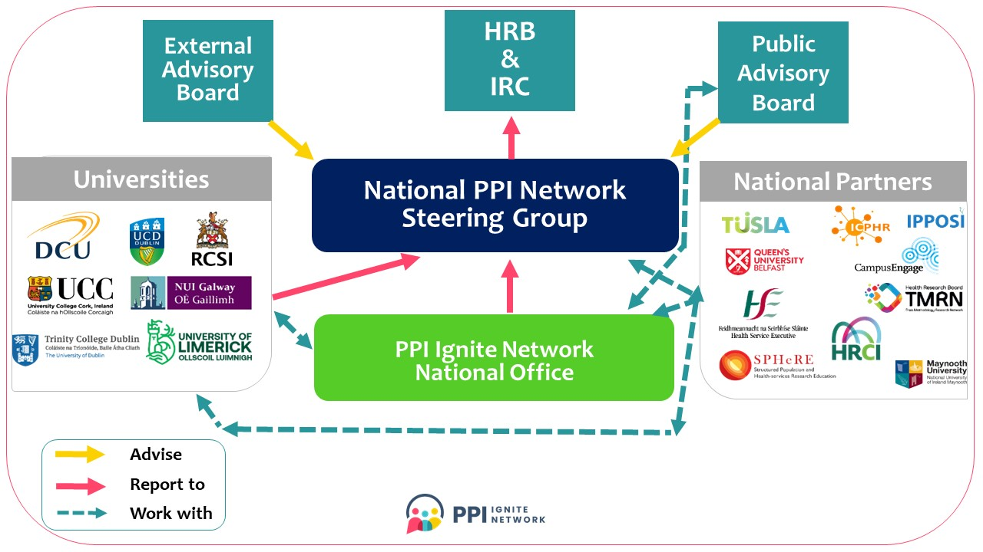

PPI Ignite Network Public Advisory Board

Expression of Interest form
Personal details
Name:
Address:
Phone:
Email:
Motivation statement: Why I would like to be a member of the Public Advisory Board
Please tell us why you want to become a member of the Public Advisory Board, and tell us any information that you feel is relevant for this role, which may be related to your personal background, your lived experience and knowledge, or your interest in research.
You can include your motivation statement in this document or you can create a video or audio recording. If you wish, you can send us a document and a video or audio recording.
Written statements should be less than 500 words. Audio or video recordings should be shorter than 3 minutes. Longer recordings will be accepted from any person with special communication needs.
Write motivation statement here.

Please provide details of 2 referees: i.e., suitable persons known to you to provide a character reference (name, address or professional affiliation, email, phone, context in which they know you)
- First referee
- Second referee
Timing of meetings
The Public Advisory Board meetings will take place during the working week (Monday to Friday). What times would you usually be able to join a 2 hour meeting online?
Between 9am and 1pm [ ]
Between 2pm and 5pm [ ]
Between 5pm and 7.30pm [ ]
Is there is any day or days during the week that you usually would not be able to attend:
__________________________________
Declaration
I confirm that:
 | The information that I have provided on this application has been honestly and accurately expressed to the best of my knowledge and belief.
 | I do not know, or am not aware of any conflict or potential conflict of interest, which would prevent my participation on the PPI Ignite Network Public Advisory Board
 | I will adhere to the Terms and Conditions as set out for my participation on the Public Advisory Board.
☐ | I agree that my name can be published if I become a member of the PPI Ignite Network Public Advisory Board

Signed (typed name acceptable): _____________________________
Date: _____________________________

How to send us your expression of interest
Please email this completed form to hello@ppinetwork.ie. If you record your motivation statement as an audio or video file, please include a link to the file in your email or use WeTransfer (or some other software) to send us an audio or video file. Please contact us if you have problems sending the file and we will do our best to help.
Within 48 hours of receiving your Expression of Interest, we will email you to confirm that we received it.
Closing date: 30 May 2022
Selection process
We will shortlist suitable applicants and invite them to a competencies-matching meeting with a PPI Ignite Network staff member and one or more other nominated persons. This meeting will take place online using Zoom.
Board members will be selected on the basis of their suitability displayed in their motivation statement and at the competencies-matching meeting. A panel may be formed of additional applicants meeting the eligibility criteria. This panel will be kept for 3 years and vacancies arising may be filled from the panel.
The names of members of the Public Advisory Board will be published after the first Board meeting. The PPI Ignite Network will email every person who submits an expression an interest to let them know the outcome of their expression of interest.
Data protection
Please note that all personal data shall be treated as confidential in accordance with the Data Protection Act 2018 and General Data Protection Regulations (GDPR). All documents (expressions of interest and references, when applicable) will be held by the PPI Ignite Network national office, until the Public Advisory Board is in place. Details of members of the Public Advisory Board, and of people who are included in the panel of potential additional members, will be held for the duration of the Board (3 years). All Expression of Interest materials (paper and electronic) received from people who are not included on the Board or on the panel will be deleted once the Board is in place.

