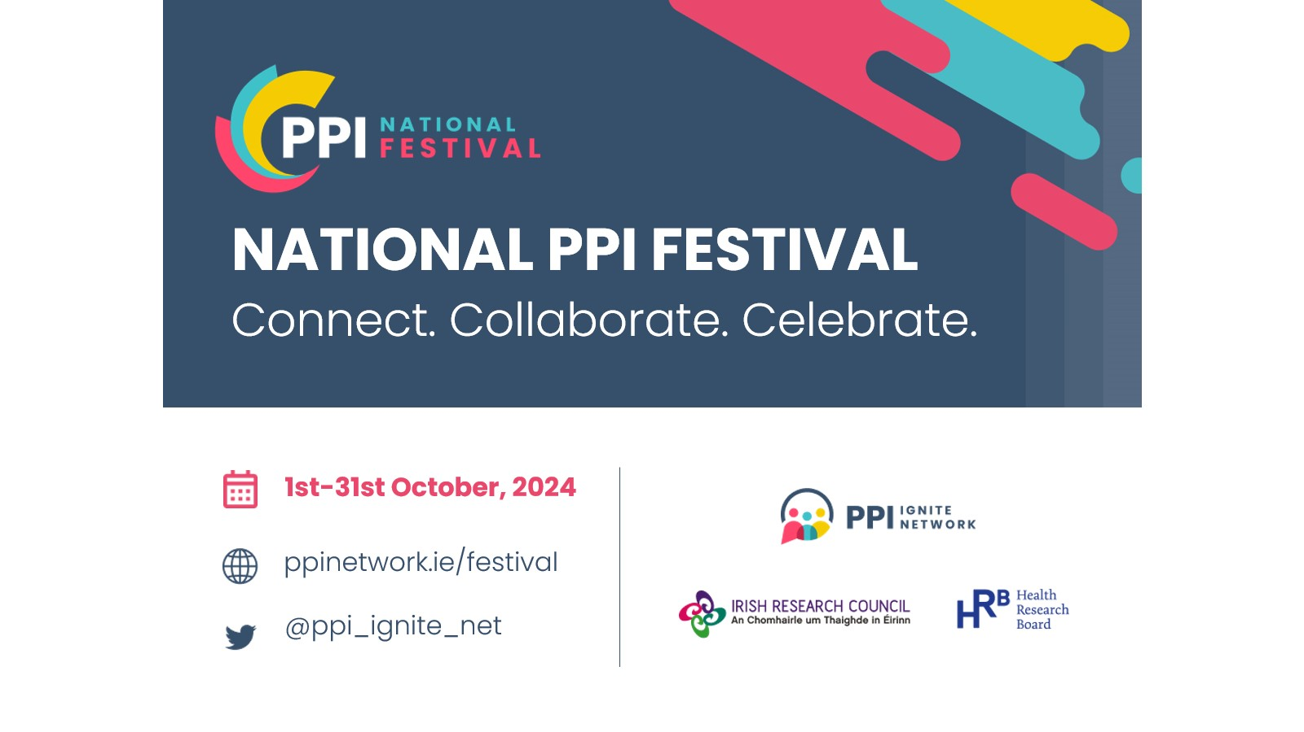

Guidelines for Event Organisers
The third National PPI Festival will shine a spotlight on the remarkable strides in public and patient involvement (PPI) in Irish research. The Festival, coordinated by the PPI Ignite Network, aims to:
- Celebrate PPI progress to date
- Provide opportunities to foster existing relationships
- Broaden out to connect with the research community not currently involved
- Increase overall public awareness of PPI
- Allow a creative space for innovation
Take a look at the impact of Festival 2023 and Festival 2022.

Note that Festival 2024 tag line is: Connect. Collaborate. Celebrate.

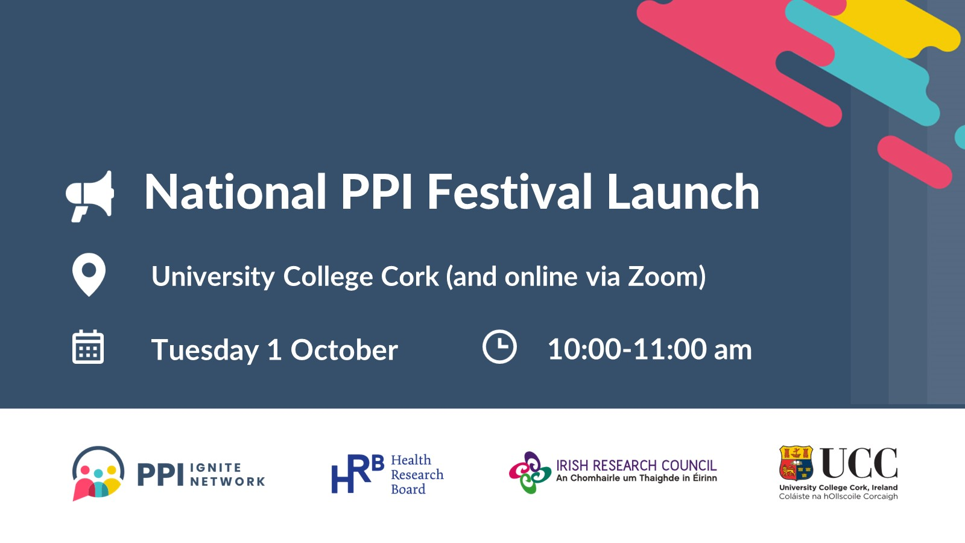

Our audiences
Our aim is that the festival reaches the general public, local communities and PPI contributors, patient organisations and charities, postgraduate students, researchers and research centres and networks, research funders, administration and management staff at universities, and members of the media.
We are now extending an invitation to all these audiences, including the Network’s local and national partners, to organise PPI-related events as part of the National PPI Festival 2024. Where possible and appropriate, we encourage potential organisers to consider collaborating with others (researchers, community, or patient organisations, etc) to organise events.

The nature of the Festival
PPI-related Festival events will be organised all over Ireland, including both in-person and online events. If you are considering organising a Festival event, we at the PPI Ignite Network will support you by:
- Providing editable promotional PowerPoint templates, with the festival branding, which you can choose to use to advertise your event
- Inviting you to submit your event to the Network’s Calendar of Events, which will be the central Festival calendar
- Promoting your event via our newsletter and on social media
- Providing you with an event feedback template or some specific questions to add to your own event feedback process, to help gather feedback and information on the impact of the Festival (see Appendix A for details)
- Pointing you to the PPI Ignite Network’s Values and Principles Framework to underpin your event planning
- Sharing the Festival press release with you, if you are planning a press release for your event

We welcome Festival events that are open to all, or events targeted as specific audiences, for example, a particular patient or community organisation, students on a particular course or attending a specific University, or a specific cohort of university staff, for example, University research office staff. There is great merit in both open and targeted events, with the mix of events helping to extend the festival reach and impact in many different ways.
We encourage creativity in event planning and invite event organisers to consider innovative methods to engage attendees and promote PPI, such as art installations or interactive digital platforms. We also place great importance on equity, diversity and inclusion and encourage a focus on reaching new and diverse audiences and maximising the accessibility of events for all attendees. If your event generates a PPI resource (for example a document or a video recording), we will be delighted to share this with the PPI community by linking to it from our online resources page and promoting it on social media. You may find it helpful to link an event to a relevant national or international day (see Table 1 for some examples).
Event organisers are responsible for:
- Covering any costs involved in organising an event
- Inviting attendees, managing attendee registration and communicating appropriately with registered attendees both before and after an event
- Gathering some feedback on the event and sharing feedback on the specific questions mentioned anonymously with the Network (see Appendix A)
- Using your own social media and other channels to promote your event
- Using (at a minimum) the Festival logo for any event branded a National PPI Festival Event in promotional materials and on slide presentations (if any) at events; we encourage the use of the Festival templates to promote your event
- Updating the PPI Calendar of Events by submitting the provisional date for your event as early as possible and adding further details of the event once confirmed.

Planning your press and event promotion
We will utilise social media, email newsletters, national and local press, and various university press offices for festival promotion. We ask event organisers to promote their own events as part of the “National PPI Festival".
We will use #PPIFestival2024 on social media.
When organising an event, consider these tips/questions:
- Will you promote the event locally and/or nationally on radio and/or in the press? Who will lead this? Do you need to connect up in advance with the Comms/press section of your organisations?
- Who the best person might be to talk to the local press or local radio
- Who the best person to talk to the national press or national radio
- Generate one or more usable quotes from those taking part
- How will you promote the event on social media?
- Is the event on the Festival Calendar of Events and are the registration information and event details up to date?
- Write a very brief (30-40 word) promotion for the event, aimed at a public audience, for use and re-use on social media and if contacted by the press
- When confirming speakers/contributors, ask each person to send you a headshot and request permission to use it on social media and other promotional materials, before and after the Festival
- Plan to have someone to take photos at every in-person event and obtain permission from those attending so that you and the Network can use these photos after the event online and in print

Festival themes
We anticipate that as event plans begin to take shape, we will be able to identify emerging themes that will be useful both to promote the Festival and to help audiences identify events of particular interest to them. Potential themes may include “PPI in PhD Research”, “International PPI” or “Broadening the reach of PPI”.

Queries?
National PPI Festival 2024 is being coordinated by the PPI Ignite Network @ UCC (Dr Emmy Racine emmy.racine@ucc.ie ). Each of the PPI Ignite Network Universities has a local PPI Ignite Network office, check out your local contact here. If you are planning/considering planning an event and have any questions, please touch base with a PPI Ignite Network contact and/or the national office (Edel Murphy, hello@ppinetwork.ie) and we will do our best to help you.
If you want to find out more about events or want to attend an event, please check out our online Festival information and, as events are organised, they will be displayed on the Calendar of Events.

Table 1: Special days during October
Oct 1 International Day of Older Persons
Oct 1-31 Health Literacy Month NIH
Oct 1-31 Breast Cancer Awareness Month
Oct 1-31 National Breastfeeding Week
Oct 5 World Meningitis Day
Oct 6-12 Mental Illness Awareness Week
Oct 10 World Sight Day
Oct 10 World Mental Health Day
Oct 11 National Coming Out Day
Oct 11 International Day of the Girl
Oct 12 World Hospice and Palliative Care Day
Oct 12 World Arthritis Day
Oct 13 International Day for Disaster Risk Reduction
Oct 13 World Thrombosis Day
Oct 13-19 International Infection Prevention Week IIPW
Oct 16 European Restart a Heart Day ERC
Oct 16 World Food Day
Oct 16 Global Ethics Day
Oct 18 Developmental Language Delay DLD Awareness Day
Oct 18 World Menopause Day
Oct 20 World Osteoporosis Day
Oct 20-26 National Healthcare Quality Week
Oct 29 International Psoriasis Day
Oct 29 World Stroke Day

Appendix A: Gathering evidence of impact

Why do we need to gather evidence of impact?
There is great work being done in PPI in Ireland, and this year’s festival will showcase the depth and breadth of PPI across Ireland in 2024. We need to be able to effectively demonstrate the value of our efforts across the festival’s programme, to demonstrate to decision-makers such as funders, policymakers, academic leaders and public audiences the incredible potential of PPI to advance the societal impact of research in Ireland. We also need to gather evidence and feedback to check that what we all offer is of the upmost relevance and benefit to PPI contributors, both past and future and to our research community.
How can you help?
We ask event organisers gather evidence of impact in one of the following ways:
- Option 1: Share the following link with participants/attendees to fill out the form online:
https://forms.office.com/Pages/ResponsePage.aspx?id=hrHjE0bEq0qcbZq5u3aBbJlXXxHV2QJLn95cNxbLWkZUNDlJUzQwT0ZaRE1HVjVLQVVNMVFHTzM1NS4u

If you use this link to gather feedback, no further work required! The feedback responses go directly to the PPI Ignite Network, which will allow us to gather evidence of the Festival impact nationally. If you wish, we will be happy to share the feedback for your event back with you.
- Option 2: If you have a standard event feedback form that you typically use, add these questions to that form, and send us an electronic copy of the responses to these questions, for integration with other data.

1) What PPI Festival Event did you attend?
(Allow a text box for attendees to respond)

2) What best describes you?
· Researcher/academic,
· PPI contributor/patient/member of the public
· Employee of a charity or community organisation
· Research funder
· Public agency employee
· HEI administration
· Other ________________________

3) How did you hear about this event?
(Allow a text box for attendees to respond)

4) How would you describe your level of knowledge / engagement with PPI

- This is my first interaction with the concept of PPI
- I have a little knowledge of PPI
- I have some knowledge of PPI
- I have a great deal of knowledge with PPI

5) After attending this event, please rate your level of confidence with PPI in research from your perspective (eg as a member of the public, as a researcher etc)

- Much more confident
- More confident
- Similar to before
- Less confident
- Much less confident

6) Is attending this Festival event likely to change either your outlook on PPI or how you engage with PPI?

- Very likely
- Likely
- Similar to before
- Unlikely
- Very unlikely

7) What was the key benefit or highlight for you from participating in today’s session?
(Allow a text box for attendees to respond)

